# MySQL PRACTICAL

* For working on this practical database is created named as practical.
* Then this practical database consist of different tables named as User,Product,Order,Order_Details.
* Here is screenshots of the query which were executed to create the tables.

create table USER (

user_id int not null auto_increment,

first_name VARCHAR(50),

last_name VARCHAR(50),

primary key(user_id)

);

insert into USER (first_name, last_name) values ('Xavier', 'Hanselmann');

insert into USER (first_name, last_name) values ('Eldredge', 'Abbess');

insert into USER (first_name, last_name) values ('Sigmund', 'Grigoroni');

insert into USER (first_name, last_name) values ('Lexis', 'Derry');

insert into USER (first_name, last_name) values ('Dionis', 'Overnell');

insert into USER (first_name, last_name) values ('Ellary', 'Soldner');

insert into USER (first_name, last_name) values ('Cherilyn', 'Piddletown');

insert into USER (first_name, last_name) values ('Harriott', 'Rainon');

insert into USER (first_name, last_name) values ('Boonie', 'De Zamudio');

insert into USER (first_name, last_name) values ('Siffre', 'Jaeggi');

insert into USER (first_name, last_name) values ('Natka', 'Danielsky');

insert into USER (first_name, last_name) values ('Corilla', 'Lettsom');

insert into USER (first_name, last_name) values ('Bordie', 'Plak');

insert into USER (first_name, last_name) values ('Nixie', 'Cosford');

insert into USER (first_name, last_name) values ('Rebekah', 'Braghini');

insert into USER (first_name, last_name) values ('Estrellita', 'Oleszcuk');

insert into USER (first_name, last_name) values ('Wilmer', 'Tourner');

insert into USER (first_name, last_name) values ('Lucas', 'Tritten');

insert into USER (first_name, last_name) values ('Darren', 'Melbourn');

insert into USER (first_name, last_name) values ('Cathi', 'Breitler');

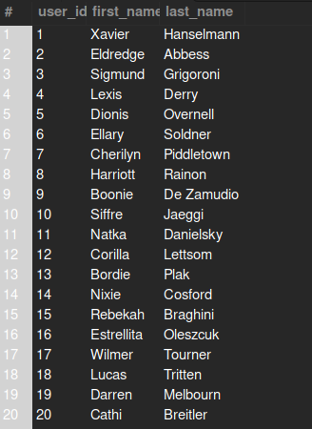

* Queries for product table .

create table PRODUCT (

product_id int not null auto_increment,

product_name VARCHAR(50),

product_value INT,

primary key(product_id)

);

* insert into PRODUCT (product_name, product_value) values ('Cream - 35%', 18);
* insert into PRODUCT (product_name, product_value) values ('Tea - Orange Pekoe', 32);
* insert into PRODUCT (product_name, product_value) values ('Cake - Dulce De Leche', 1);
* insert into PRODUCT (product_name, product_value) values ('Wine - Hardys Bankside Shiraz', 11);
* insert into PRODUCT (product_name, product_value) values ('Crab - Back Fin Meat, Canned', 48);
* insert into PRODUCT (product_name, product_value) values ('Coffee-Arabica', 28);
* insert into PRODUCT (product_name, product_value) values ('Chips', 10);
* insert into PRODUCT (product_name, product_value) values ('Bread - Wheat bread', 8);
* 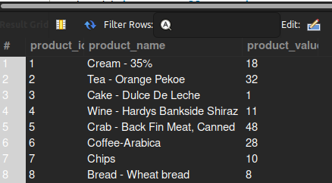

* Queries for order table generation.
* create table ORDERS (
* order_id int not null auto_increment,
* user_id int ,
* order_status varchar(255),
* order_date date ,
* delivery_date date,
* primary key(order_id),
* foreign key(user_id) references USER(user_id)
* );
* #inserting values in orders
* insert into ORDERS (user_id,order_status, order_date, delivery_date) values (9,'ordered', '2023-03-14', '2023-03-17');
* insert into ORDERS (user_id,order_status,order_date, delivery_date) values (4, 'ordered','2023-03-14', '2023-03-17');
* insert into ORDERS (user_id,order_status, order_date, delivery_date) values (5, 'ordered','2023-03-14', '2023-03-17');
* insert into ORDERS (user_id,order_status, order_date, delivery_date) values (11,'delivered', '2023-03-14', '2023-03-16');
* insert into ORDERS (user_id,order_status, order_date, delivery_date) values (11, 'ordered','2023-03-14', '2023-03-17');
* insert into ORDERS (user_id,order_status,order_date, delivery_date) values (9, 'delivered','2023-03-15', '2023-03-16');
* insert into ORDERS (user_id,order_status,order_date, delivery_date) values (9, 'ordered','2023-03-15', '2023-03-17');
* insert into ORDERS (user_id,order_status,order_date, delivery_date) values (7, 'delivered','2023-03-15', '2023-03-16');
* insert into ORDERS (user_id,order_status, order_date, delivery_date) values (6,'ordered', '2023-03-14', '2023-03-17');
* insert into ORDERS (user_id,order_status, order_date, delivery_date) values (9, 'ordered','2023-03-15', '2023-03-17');
* insert into ORDERS (user_id,order_status, order_date, delivery_date) values (1, 'delivered','2023-03-15', '2023-03-16');
* insert into ORDERS (user_id,order_status, order_date, delivery_date) values (3, 'ordered','2023-03-14', '2023-03-17');
* insert into ORDERS (user_id,order_status, order_date, delivery_date) values (2, 'delivered','2023-03-15', '2023-03-16');
* insert into ORDERS (user_id,order_status, order_date, delivery_date) values (1, 'delivered','2023-03-15', '2023-03-16');
* insert into ORDERS (user_id,order_status, order_date, delivery_date) values (9, 'delivered','2023-03-14', '2023-03-16');
* insert into ORDERS (user_id,order_status, order_date, delivery_date) values (1, 'ordered','2023-03-15', '2023-03-17');
* insert into ORDERS (user_id,order_status, order_date, delivery_date) values (13, 'delivered','2023-03-14', '2023-03-16');
* insert into ORDERS (user_id,order_status, order_date, delivery_date) values (6, 'delivered','2023-03-15', '2023-03-16');
* insert into ORDERS (user_id,order_status, order_date, delivery_date) values (13,'ordered', '2023-03-14', '2023-03-17');
* insert into ORDERS (user_id,order_status, order_date, delivery_date) values (12, 'delivered','2023-03-15', '2023-03-16');

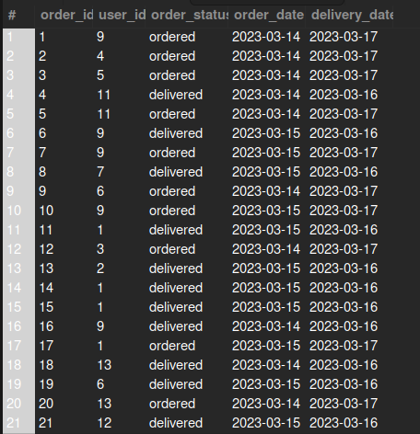

* Queries for Order_details.
* create table ORDER_DETAILS (
* order_id INT,
* product_id INT,
* foreign key(order_id) references ORDERS(order_id),
* foreign key(product_id) references PRODUCT(product_id)
* );
* insert into ORDER_DETAILS (order_id, product_id) values (14, 3);
* insert into ORDER_DETAILS (order_id, product_id) values (20, 3);
* insert into ORDER_DETAILS (order_id, product_id) values (16, 6);
* insert into ORDER_DETAILS (order_id, product_id) values (13, 8);
* insert into ORDER_DETAILS (order_id, product_id) values (13, 3);
* insert into ORDER_DETAILS (order_id, product_id) values (6, 3);
* insert into ORDER_DETAILS (order_id, product_id) values (7, 7);
* insert into ORDER_DETAILS (order_id, product_id) values (5, 2);
* insert into ORDER_DETAILS (order_id, product_id) values (10, 8);
* insert into ORDER_DETAILS (order_id, product_id) values (16, 7);
* insert into ORDER_DETAILS (order_id, product_id) values (3, 2);
* insert into ORDER_DETAILS (order_id, product_id) values (1, 6);
* insert into ORDER_DETAILS (order_id, product_id) values (4, 5);
* insert into ORDER_DETAILS (order_id, product_id) values (9, 2);
* insert into ORDER_DETAILS (order_id, product_id) values (20, 2);
* insert into ORDER_DETAILS (order_id, product_id) values (10, 6);
* insert into ORDER_DETAILS (order_id, product_id) values (13, 7);
* insert into ORDER_DETAILS (order_id, product_id) values (15, 7);
* insert into ORDER_DETAILS (order_id, product_id) values (8, 8);
* insert into ORDER_DETAILS (order_id, product_id) values (7, 2);
* 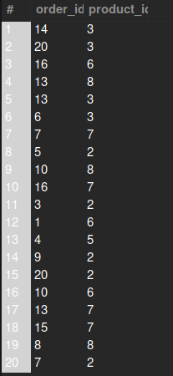
* Now writing query for Fetch all the User order list and include atleast following details in that.
* Customer name
* Product names
* Order Date
* Expected delivery date (in days, i.e. within X days).
* select USER.first_name,USER.last_name,PRODUCT.product_name,ORDERS.order_date,ORDERS.delivery_date-ORDERS.order_date AS delivery_days from USER INNER JOIN ORDERS on USER.user_id=ORDERS.user_id inner join ORDER_DETAILS on ORDERS.order_id=ORDER_DETAILS.order_id inner join PRODUCT on ORDER_DETAILS.product_id=PRODUCT.product_id;

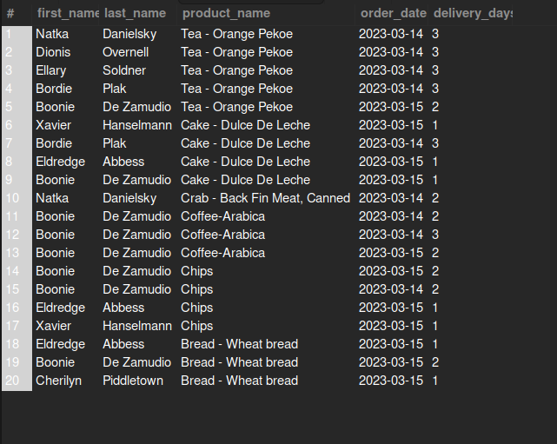

* Query for All undelivered Orders
* select * from ORDERS AS o where o.order_status="ordered";
* 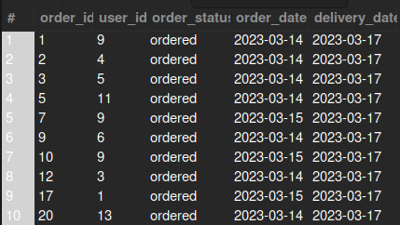
* Query for 5 Most recent orders
* select * from ORDERS AS o order by o.order_date DESC limit 5;
* 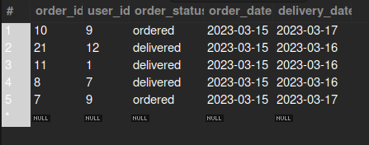
* Query for Top 5 active users (Users having most number of orders)
* select u.first_name,u.last_name from USER as u inner join ORDERS AS o on u.user_id=o.user_id group by o.user_id order by count(o.order_id) desc limit 5;
* 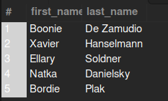
* Query for inactive users
* select u.first_name,u.last_name from USER as u left join ORDERS as o on u.user_id=o.user_id where o.order_id is null;
* 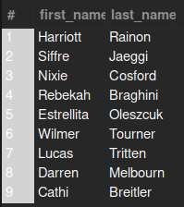
* Query for top 5 purchased product
* select p.product_name from PRODUCT AS p inner join ORDER_DETAILS AS o on p.product_id=o.product_id group by p.product_id order by count(o.order_id) desc limit 5;
* 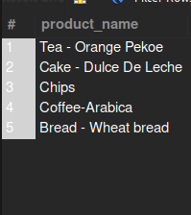
* Query for Most expensive and most chepest orders.
* (select o.order_id ,sum(o.product_id*p.product_value)as value from ORDER_DETAILS AS o inner join PRODUCT AS p on p.product_id=o.product_id group by o.order_id order by value limit 1)
* union
* (select o.order_id ,sum(o.product_id*p.product_value)as value from ORDER_DETAILS AS o inner join PRODUCT AS p on p.product_id=o.product_id group by o.order_id order by value desc limit 1);
* 